- UK prime minister Rishi Sunak has announced that a general election will take place on July 4. While there are likely to be some differences in manifesto tax and spending pledges, the poor fiscal inheritance and apparent reluctance of either party to materially alter the flawed fiscal rules suggest the election outcome is unlikely to significantly affect the near-term outlook.
- CPI inflation slowed in April, but a disappointingly small fall in services inflation has almost certainly killed the chances of a June rate cut. We now expect two 25bps cuts this year, in August and November. But a third cut remains possible if pay and inflation data soften more quickly than anticipated or an incoming Labour government opts to front-load fiscal tightening.
This week's important economic data was rather overshadowed by political developments, with prime minister Rishi Sunak announcing that an early general election will take place on July 4, several months earlier than most political commentators had anticipated.
There's been limited market reaction to the news so far. This reflects two key factors. First, the polls have consistently reported that Labour are well ahead of the Conservatives, so market participants and the broader public have become accustomed to the idea that Labour is very likely to form the next government (Chart 1). Second, so far neither party has suggested materially changing the fiscal framework. So an incoming Labour administration would have little room for manoeuvre and would likely need to significantly tighten fiscal policy during the new parliament.
Once the main parties have published their manifestos, we plan to run the proposals through our Global Economic Model to assess the potential impact on the economy. We hope the plans will be bolder than those mooted so far – we've demonstrated that overhauling the fiscal framework could boost GDP while still lowering the debt-to-GDP ratio. But with Labour apparently keen to avoid accusations of fiscal indiscipline, bolder reforms would probably have to wait until they take power.
Chart 1: Most polls suggest Labour's current lead is vast
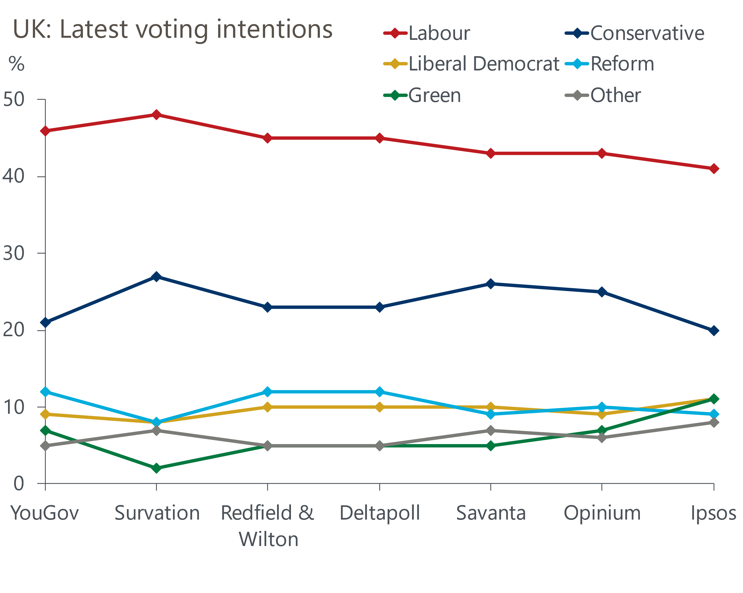
Source: Oxford Economics

Until the general election announcement, the inflation release and associated interest rate implications had looked set to be the week's dominant story. Despite falling to 2.3% from 3.2%, CPI inflation surprised to the upside slightly in April. Half of the drop in the annual rate came from the energy category, as Ofgem's near-12% cut in the price cap came into effect. Meanwhile, food price inflation continued to weaken.
But arguably the most important news was on services inflation. There was a high degree of uncertainty going into this week's release, as April's data included once-a-year price hikes for index-linked contracts and regulated prices. In the event, the price increases in many of these sectors were larger than expected. And broad-based strength elsewhere meant that the m/m rise in services prices was only marginally smaller than last year's bumper increase (Chart 2).
Chart 2: The m/m rise in services prices was almost as high as April 2023's huge increase
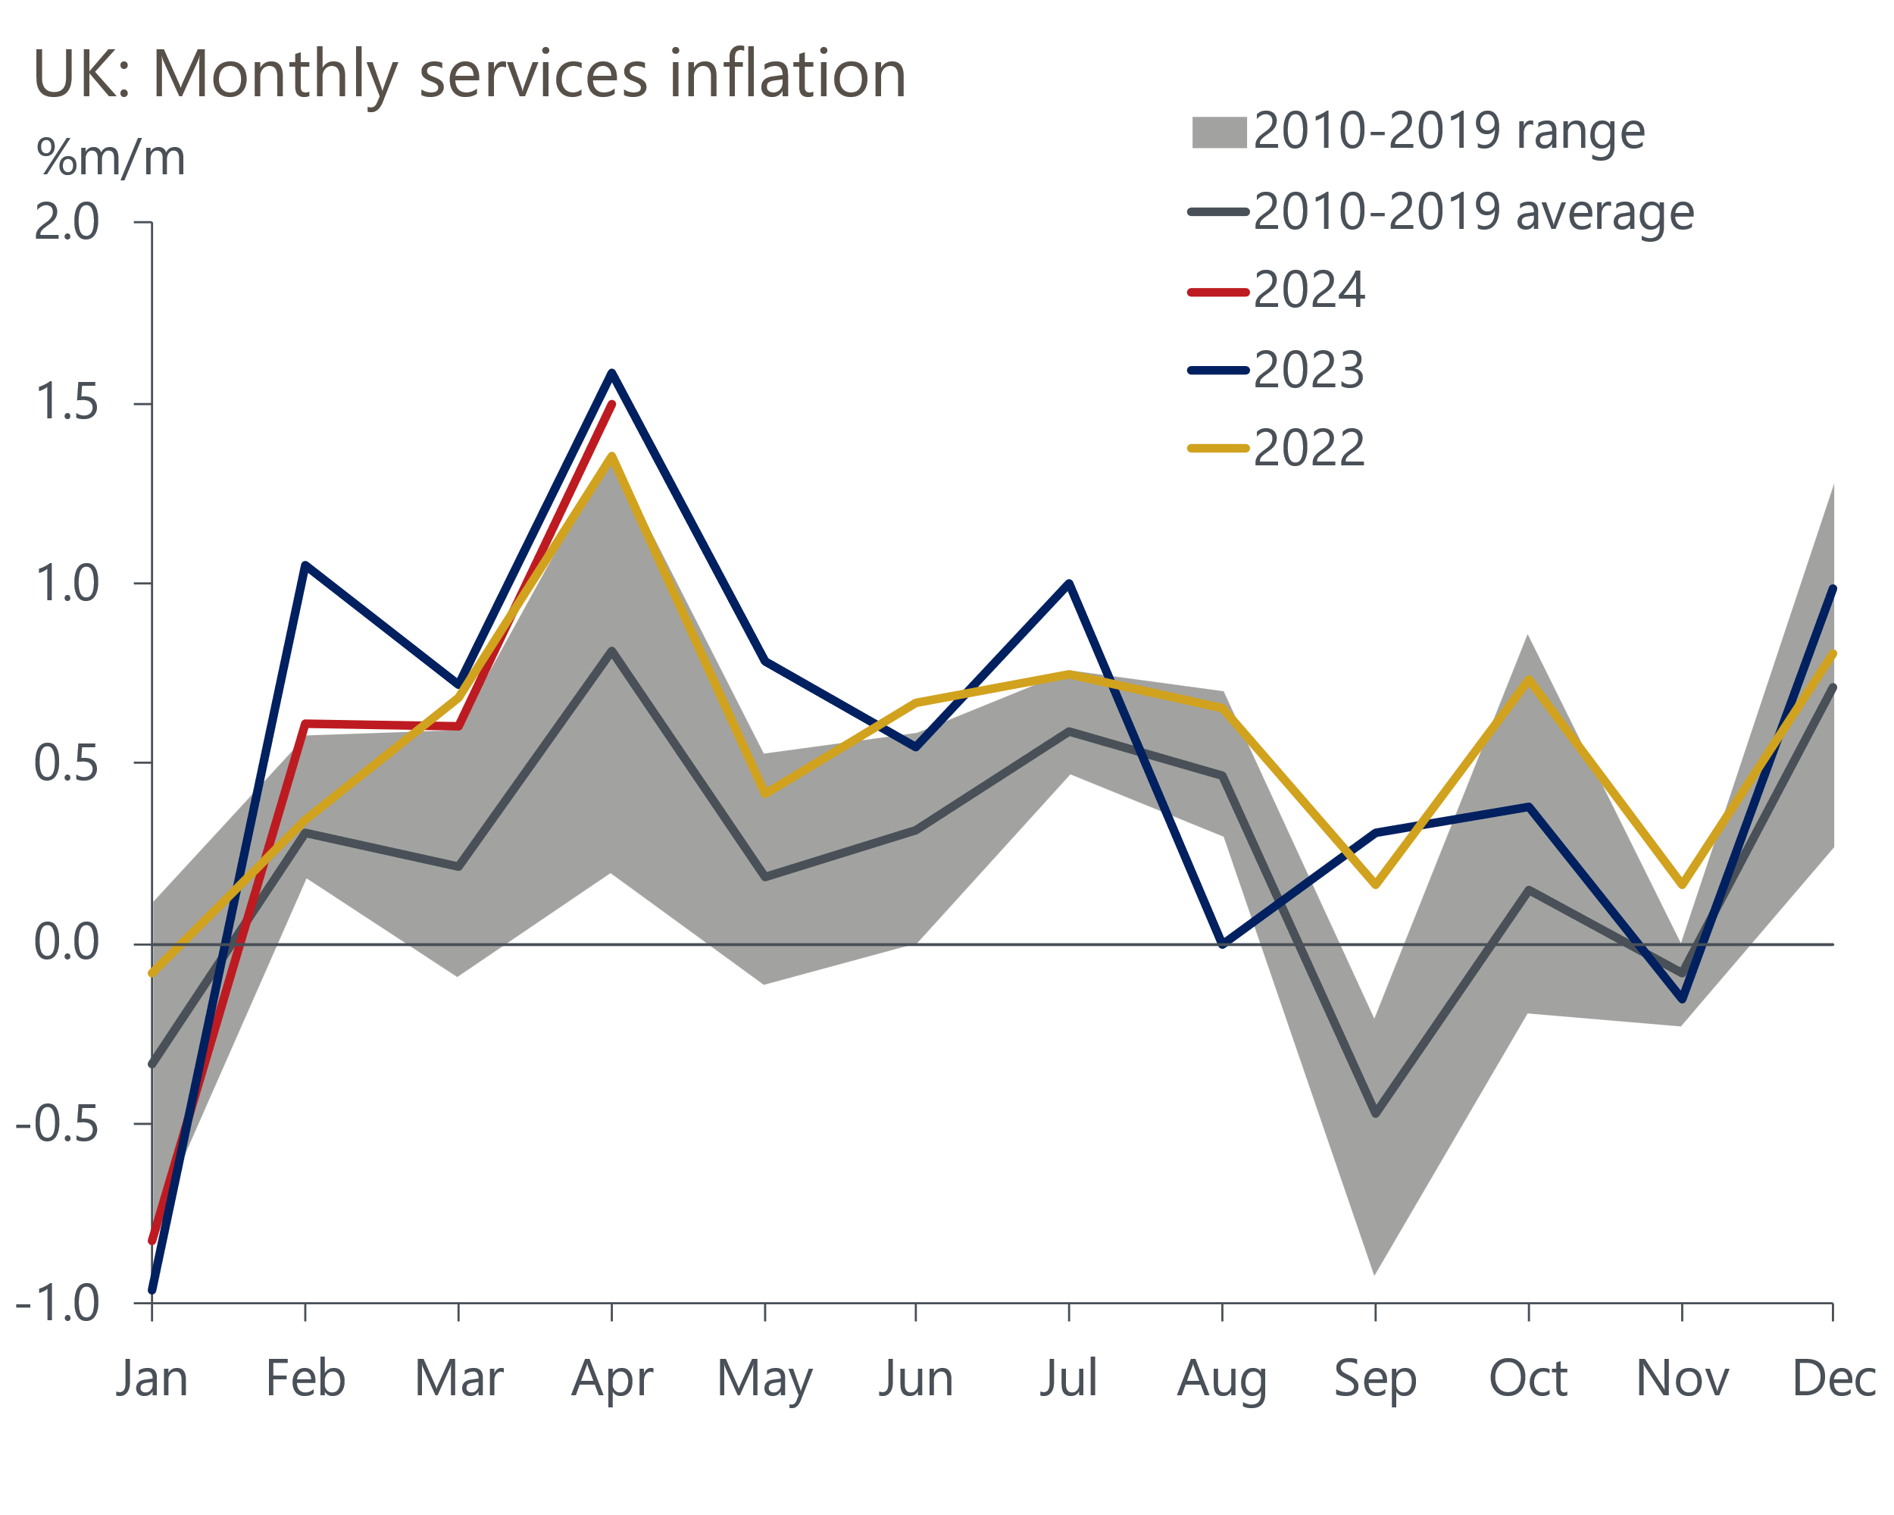
Source: Oxford Economics calculations using data from Haver Analytics
Together with private sector regular pay growth, services inflation is seen as the most important indicator of inflation persistence by the Bank of England's Monetary Policy Committee. April's outturn was 0.4ppts higher than the latest BoE staff forecast, so the prospect of a June rate cut now looks very remote.
In response, we have changed our BoE call and now expect the first rate cut to come in August. Disappointing though April's data was, with special factors at play we don't see it as a signal that we will see persistently higher m/m changes in services prices in subsequent months. Much weaker services cost and price balances in this week's May flash S&P Global survey supported this view.
The MPC will see two further inflation prints ahead of its August meeting and our forecast shows services inflation slowing in the coming months as base effects continue to come into play and the indirect effects of lower energy prices start to drag on prices more significantly. Furthermore, there has been a clear dovish shift in the MPC's balance and tone in recent months, which suggests the committee is keen to loosen policy, barring any further surprises.
Indeed, we still think there's a reasonable chance of three 25bps cuts this year, if pay and inflation data slows more quickly than we anticipate, or an incoming Labour government decides to front-load the fiscal tightening. But the later start to the rate cutting cycle means that we now narrowly favour two 25bps cuts for our baseline forecast, taking Bank Rate to 4.75% by the end of the year.
The prospect of lower inflation and the eventual passthrough of rate cuts should be a positive for the retail sector. The ONS suggested poor weather was behind April's 2.3% m/m drop in retail sales volumes, and we expect sales to rebound in May, as they did after December's similarly unexpected slump. We remain cautiously optimistic about the consumer outlook for H2 2024, with real wages growing strongly and improving confidence suggesting that real income gains are more likely to translate into stronger consumer spending than they have recently.

The week ahead
The only release of note next week is the Bank of England's data on household lending and deposits. The uptick in mortgage interest rates in recent months has taken some of the momentum out of the recovery in mortgage demand, with March's rise in mortgage approvals being much smaller than in the two months prior. We think this trend is likely to have continued in April given quoted mortgage rates drifted higher that month. Therefore, we forecast mortgage approvals held steady at the 61,300 mark in April.
Owing to the time lag between a mortgage being approved and funds being dispensed, the recovery in mortgage demand in early 2024 should support a rebound in net mortgage lending. There could also be a boost from repayments dropping back from March's high level. So we expect net secured lending to have risen to £2.1bn in April.
Net unsecured lending rose to £1.6bn in March from £1.4bn in February, with a very strong increase in gross lending mitigated by repayments reaching a record high. We expect both gross lending and repayments to have normalised in April, which would leave net unsecured lending unchanged at £1.6bn.
Table 1: Week ahead calendar
Date | Events | Period | Measure | Unit | Previous | Forecast
May 31 | Mortgage approvals | Apr | Level | 000s | 61.3 | 61.3
May 31 | Mortgage lending | Apr | Net lending | £bn | 0.3 | 2.1
May 31 | Consumer credit | Apr | Net lending | £bn | 1.6 | 1.6
May 31 | Nationwide house prices | May | m/m | % | -0.4 | 0.1
May 31 | Nationwide house prices | May | y/y | % | 0.6 | 0.8
Source: Oxford Economics

Key forecasts
Table 2: UK forecast overview
(Annual percentage changes unless specified)
 | 2022 | 2023 | 2024 | 2025 | 2026 | 2027
GDP | 4.3 | 0.1 | 0.9 | 2.0 | 1.9 | 1.6
Private consumption | 4.8 | 0.2 | 0.7 | 2.6 | 2.2 | 1.6
Fixed investment | 8.0 | 2.2 | -0.5 | 0.8 | 2.7 | 2.1
Government consumption | 2.3 | 0.5 | 3.4 | 2.8 | 1.6 | 1.5
Exports of goods and services | 9.0 | -0.5 | -0.9 | 2.7 | 2.3 | 1.7
Imports of goods and services | 14.6 | -1.5 | 0.2 | 4.7 | 2.9 | 1.9
Industrial Production | -3.5 | -0.4 | 0.3 | 0.9 | 1.5 | 1.2
Consumer prices | 9.1 | 7.3 | 2.3 | 2.2 | 2.3 | 2.2
Unemployment rate (%) | 3.9 | 4.0 | 4.3 | 4.0 | 3.8 | 3.8
Current a/c balance (% of GDP) | -3.1 | -3.3 | -2.7 | -3.1 | -3.2 | -3.1
Government balance (% of GDP) | 4.4 | 5.0 | 3.6 | 3.1 | 2.3 | 1.5
Cen. bank policy rate (%, EOP) | 3.50 | 5.25 | 4.50 | 3.50 | 2.50 | 2.00
10yr govt. bond yield (%, EOP) | 3.67 | 3.54 | 3.92 | 3.53 | 3.07 | 2.85
Exchange rate (US$ per £, EOP) | 1.20 | 1.27 | 1.26 | 1.27 | 1.30 | 1.32
Exchange rate (euro per £, EOP) | 1.13 | 1.15 | 1.17 | 1.17 | 1.17 | 1.16
Source: Oxford Economics
Table 3: Quarterly forecasts for the UK
 | 2024 |  |  |  | 2025
 | Q1 | Q2 | Q3 | Q4 | Q1 | Q2 | Q3 | Q4
GDP (% year) | 0.2 | 0.5 | 1.0 | 1.9 | 1.7 | 2.0 | 2.1 | 2.2
CPI inflation (% year) | 3.5 | 1.9 | 1.8 | 2.1 | 2.0 | 2.0 | 2.3 | 2.3
Bank Rate (%, EOP) | 5.25 | 5.00 | 4.75 | 4.50 | 4.25 | 4.00 | 3.75 | 3.50
10yr gilt yield (%, EOP) | 3.95 | 4.10 | 3.99 | 3.92 | 3.83 | 3.74 | 3.64 | 3.53
US$ per £ (EOP) | 1.26 | 1.25 | 1.25 | 1.26 | 1.26 | 1.26 | 1.27 | 1.27
Euro per £ (EOP) | 1.17 | 1.17 | 1.17 | 1.17 | 1.17 | 1.17 | 1.17 | 1.17
Source: Oxford Economics

Latest Country Economic Forecast:
May 15, 2024

Recent publications

Data Insights
Sharp fall in retail sales points to softer GDP growth in Q2
Composite PMI falls, but recovery still running at a solid pace
Inflation overshoot complicates matters for the BoE
A poor start to the new fiscal year
Pay data offers something for doves and hawks alike

Research Briefings
Why the BoE can and will cut before the Fed
How quickly are indirect effects on core inflation fading?
Dovish MPC signals a summer rate cut is likely
MPC preview – Edging closer to rate cuts
Nowcast shows wage growth slowing sharply

Contacts

Oxford Economics' UK team
- Andrew Goodwin - Chief UK Economist - agoodwin@oxfordeconomics.com
- Edward Allenby - UK Economist - eallenby@oxfordeconomics.com

